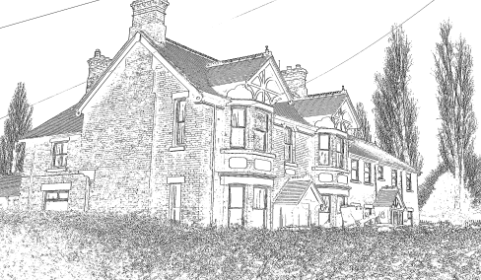
Mansfield Medical Centre
Partners:
Dr Jane Smith
Dr Ed Cowan
56 Binley Road
Coventry
CV3 1JB
Tel: 02476 457 551
Email: mansfield.medical@nhs.net

Proof of ID – Adult only

Welcome to Mansfield Medical Centre, please complete the attached forms answering all the questions in full.

We will require your NHS number. Your previous Medical Centre will be able to provide this to you.

We will require 2 forms of Identification from you

- Photo Identification:
Passport, Driving Licence, Home Office ID Card or European ID Card.
- Address Verification:
Utility Bill or Bank Statement dated with in the last 3 months.

By providing your mobile number you are consenting to receiving appointment reminders from Mansfield Medical Centre. If you do NOT want to receive these messages please sign here ……………………………………………………………………………..

We offer Patients access to Online Services via our website. This will give you online access to book appointments and order repeat prescription. You will automatically be provided with access. If you do NOT wish to have online access please sign here

…………………………………………………………………………………..

Thank you for choosing Mansfield Medical Centre

Dr Jane Smith & Dr Ed Cowan

