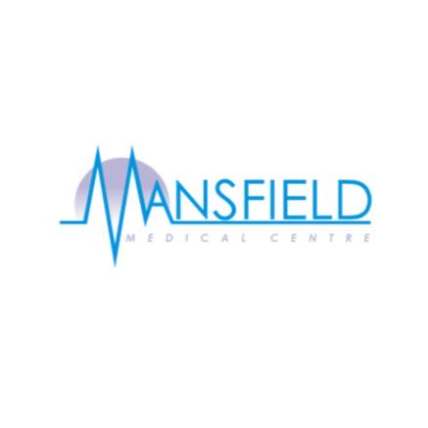 **Mansfield Medical Centre**

**SURGERY NEWSLETTER**

September - November 2024

**RSV Vaccination FLU Vaccination**

|  |
| --- |
| Respiratory Syncytial Virus (RSV) is a common cause of coughs and colds. It usually gets better by itself, but it can be serious for some babies and older adults.  The practice will invite eligible patients for their vaccine.  respiratory illness vaccine programme ... |

|  |
| --- |
| Flu vaccinations for pregnant women and children's flu cohorts will commence on Sunday, September 1, 2024. The main flu and COVID-19 vaccination campaign will begin on Thursday, October 3, 2024.  The practice will contact eligible patients with a booking link to make an appointment when flu vaccinations are available at the practice. Appointments will be available on Saturdays and one Sunday.  Each year, we are fortunate to be supported by our great team, who work on their days off to ensure the smooth running of the clinics.  Fall 2024 Flu Shot Clinic |

 **Mansfield Medical Centre**

**SURGERY NEWSLETTER**

September - November 2024

**Autumn Covid booster**

|  |
| --- |
| Patients aged 65 or over who are clinically vulnerable will be eligible for a booster dose o the covid vaccine this autumn.  Covid vaccinations will be organised by Sowe Valley PCN with appointment at the cricket club.  The covid booster programme is expected to stat in October 2024.  The Sowe Valley PCN have already started making contact eligible patient via text. |

**Protected Learning Time Join the PPG**

|  |
| --- |
| The surgery closes for important staff mandatory training for clinical and non-clinical staff, on the following dates from 12:30pm  **Wednesday 9th October 2024**  **Wednesday 20th November 2024**  The surgery will open at the normal time the following morning. |

|  |
| --- |
| The surgery meets on a quarterly basis.  If you would like to get involved please either complete the PPG form online at <https://www.mansfieldmedicalcentre.nhs.uk> or email [Mansfield.medical@nhs.net](mailto:Mansfield.medical@nhs.net) and we will contact you with further information**.** |



**Positive feedback from our patients**

“Staff are approachable and willing to help.”

“Patchs is easy to use, the requests seem to get through quickly, and the healthcare team get back to me the same day, either with a text or phone call”

“It's nice to not wait on the phone.”

**Help us improve.**

|  |
| --- |
| We have had a good response from you about the services we offer, and this is reflected in your feedback, with 70% rating the service very good/good over the last three months.  We do strive to achieve to a great service here at Mansfield Medical Centre and we would like to thank you for your comments, so we can get a better understanding of the 6% who feel the service could improve. |

**Tell us how we are doing.**

|  |
| --- |
| We all work very hard at Mansfield Medical Centre to provide a high quality and responsive service.  Please use the link below to provide us with your feedback.  <https://www.mansfieldmedicalcentre.nhs.uk/FriendsAndFamily/> |